Step 1: Understand and Define the Problem (Analyze)

- Create a logic circuit that sounds an alarm when the car is in motion and either one of the front seatbelts is not engaged while a driver or passenger is present in the car, while the ignition is on.
- The DRIV or PASS sensors give off HIGH if the presence of a driver or a passenger is detected.
- The IGN is HIGH if the ignition is on.
- The ^BELTD or ^BELTP become HIGH if the driver or passenger seatbelt is not engaged

Conditions for the alarm to sound would be:
- The driver is present AND the belt is unfastened
Or
- The passenger is present AND the belt is unfastened
AND
- The ignition is on.

Step 2: Organize and Describe the Data

Symbol | Meaning | Type | Active logic
DRIV | Indicates the presence of a driver | input | 1
PASS | Indicates the presence of a passenger | Input | 1
BELTD’ | Indicates the Driver’s seatbelt is not engaged | Input | 0
BELTP’ | Indicates the Passenger’s seatbelt is not engaged | Input | 0
IGN | Indicates the car ignition is on | Input | 1
Alarm | Alarm signal | output | 0

Step 3.1: Plan the Solution (Design the Algorithm)

- Check IGN status
- Check if driv is seated and belt is not fastened
DRIV = 1 AND BELTD’=0
- Check if passenger is seated and belt fastened
PASS = 1 AND BELTP’ =0
- If either of the above is true, alarm is on (0).
- If both point 2 and 3 are FALSE, alarm is off.

3.2 TRUTH TABLE
IGN | DRIV | PASS | BELTD’ | BELTP’ | Alarm
1 | 0 | 0 | 0 | 0 | 1
1 | 0 | 0 | 0 | 1 | 1
1 | 0 | 0 | 1 | 0 | 1
1 | 0 | 0 | 1 | 1 | 1
1 | 0 | 1 | 0 | 0 | 1
1 | 0 | 1 | 0 | 1 | 1
1 | 0 | 1 | 1 | 0 | 1
1 | 0 | 1 | 1 | 1 | 1
1 | 1 | 0 | 0 | 0 | 0, Alarm is ON
1 | 1 | 0 | 0 | 1 | 0, Alarm is ON
1 | 1 | 0 | 1 | 0 | 1,
1 | 1 | 0 | 1 | 1 | 1
1 | 1 | 1 | 0 | 0 | 0, Alarm is ON
1 | 1 | 1 | 0 | 1 | 0, Alarm is ON
1 | 1 | 1 | 1 | 0 | 0, Alarm is ON
1 | 1 | 1 | 1 | 1 | 1,

3.3 Flow Chart
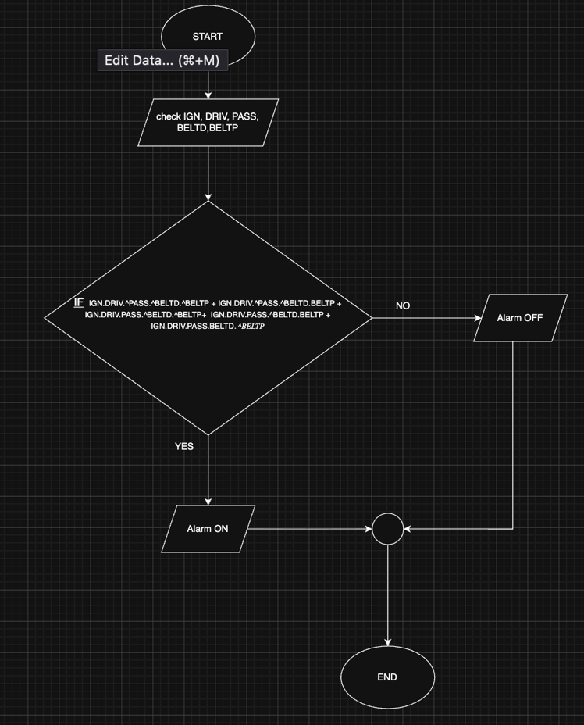

3.4 Boolean expression:
For the Alarm to be ON:
IGN.DRIV.$\overline{PASS}$.$\overline{BELTD}$.$\overline{BELTP}$
IGN.DRIV.$\overline{PASS}$. $\overline{BELTD}$.BELTP
IGN.DRIV.PASS. $\overline{BELTD}$. $\overline{BELTP}$
IGN.DRIV.PASS. $\overline{BELTD}$.BELTP
IGN.DRIV.PASS.BELTD. $\overline{BELTP}$

ALARM = IGN.DRIV.$\overline{PASS}$.$\overline{BELTD}$.$\overline{BELTP}$+ IGN.DRIV.$\overline{PASS}$. $\overline{BELTD}$.BELTP + IGN.DRIV.PASS. $\overline{BELTD}$. $\overline{BELTP}$ + IGN.DRIV.PASS. $\overline{BELTD}$.BELTP + IGN.DRIV.PASS.BELTD. $\overline{BELTP}$
3.5 Pseudocode:
START
GET IGN, DRIV, PASS, BELTD, BELTP
IF IGN.DRIV.$\overline{PASS}$.$\overline{BELTD}$.$\overline{BELTP}$+ IGN.DRIV.$\overline{PASS}$. $\overline{BELTD}$.BELTP + IGN.DRIV.PASS. $\overline{BELTD}$. $\overline{BELTP}$ + IGN.DRIV.PASS. $\overline{BELTD}$.BELTP + IGN.DRIV.PASS.BELTD. $\overline{BELTP}$
Then ALARM = 0 # ON
Else ALARM = 1 #OFF
END

Step 4: Verify and debug

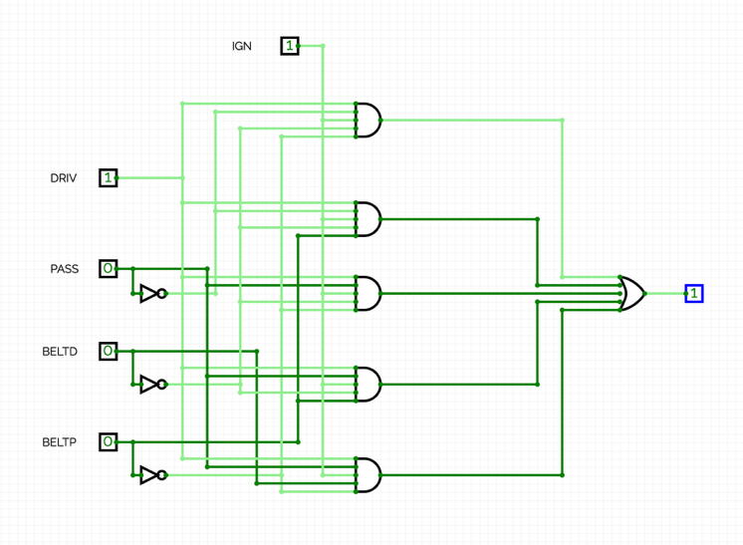
Input: DRIV.^PASS.^BELTD.^BELTP
Output: 0
Conclusion: The alarm will turn on as the driver is present in the car and the belt is unfastened while the ignition is on.

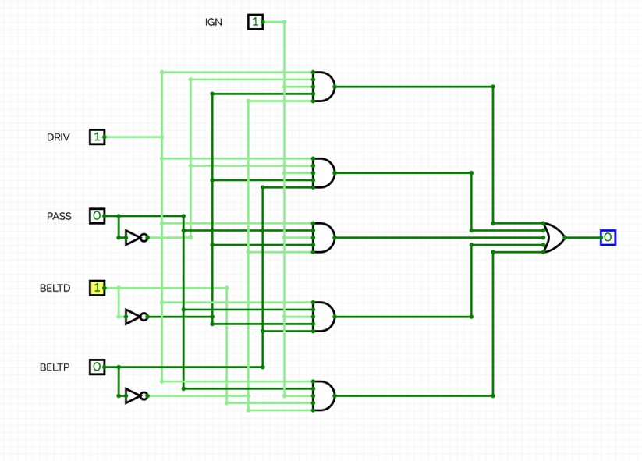
Input: DRIV.^PASS.BELTD.^BELTP
Output: 0
Conclusion: The alarm is off as the driver’s seatbelt is fastened while the ignition is on.

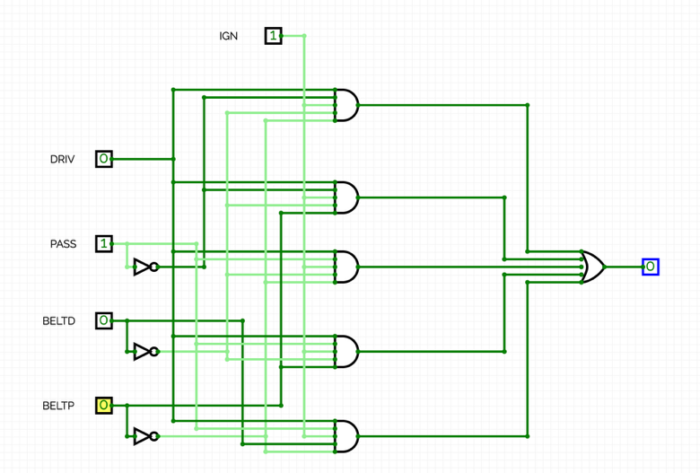
Input: ^DRIV.PASS.^BELTD.^BELTP
Output: 0
Conclusion: The alarm is off even though the Passenger is present and has an unfastened seatbelt with ignition on because the driver is not present in the car.

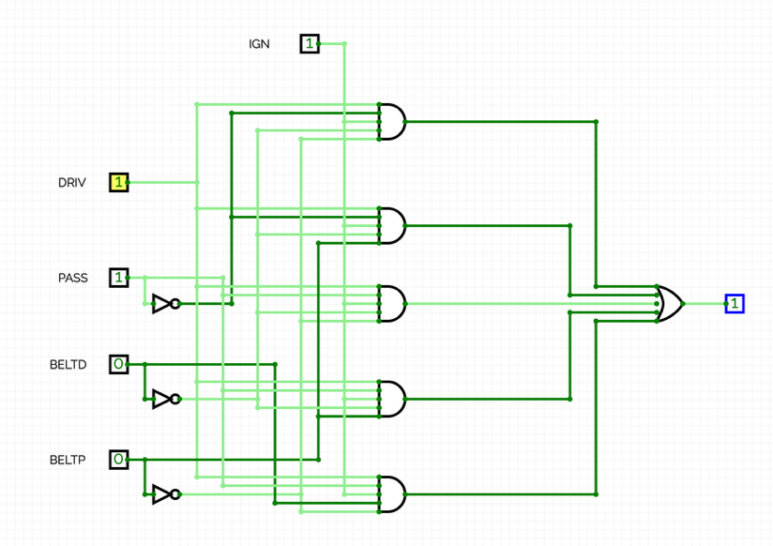
Input: DRIV.PASS.^BELTD.^BELTP
Output: 0
Conclusion: The alarm is on as both the driver and the passenger are present in the car with an unfastened seatbelt while the ignition is on.

